Problem 1:

Use the Box-Mueller method to generate a set of 3 Gaussian variables xi, yi, and zi according the probability distribution provided.
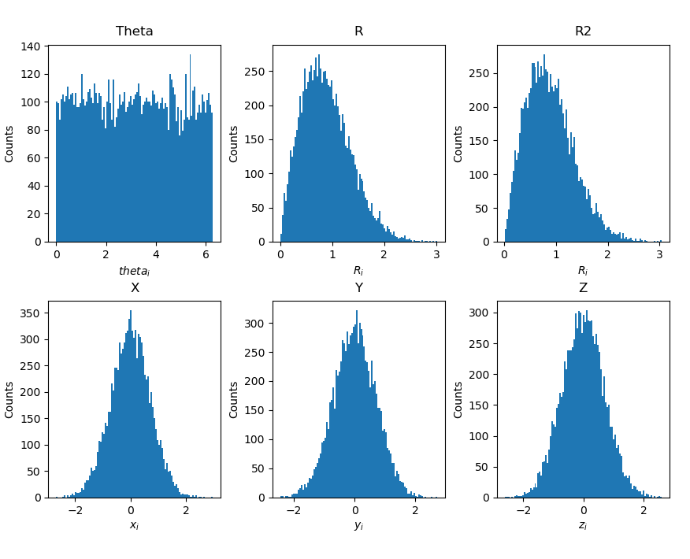

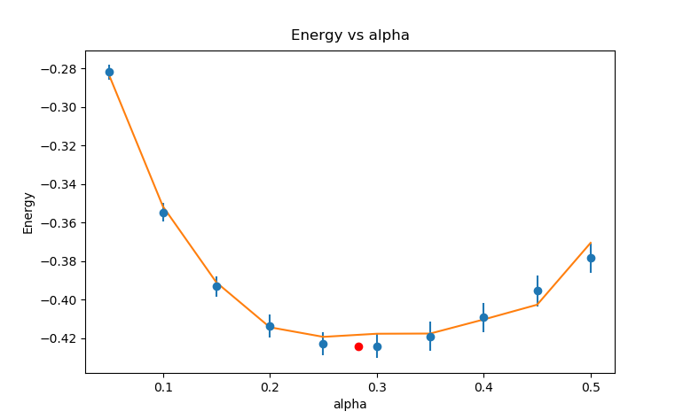
Plot your variation energy as a function of α using the standard deviation error as your error bar. Hand in this plot.

The red dot is the theoretical minimum (derived on next page)

What is the value of α which minimizing EV in this case? Check your numerical answer by doing the minimization analytically.

Numerically my minimum point is approximately:

alpha = 0.3
Energy = - 0.424

What are the analytical values of α and EV ?

Problem 2:

Now use the Metropolis algorithm. Adjust r_max so that the proposed change is accepted about 50% to 30% of the time. After you have updated 100-200 times, (allowing the system to equilibrate to its equilibrium distribution), evaluate the variational energy as a function of α. Plot your variation energy as a function of α and use the standard error as your error bar. Plot in the same graph, also a curve corresponding to the expected theoretical result:
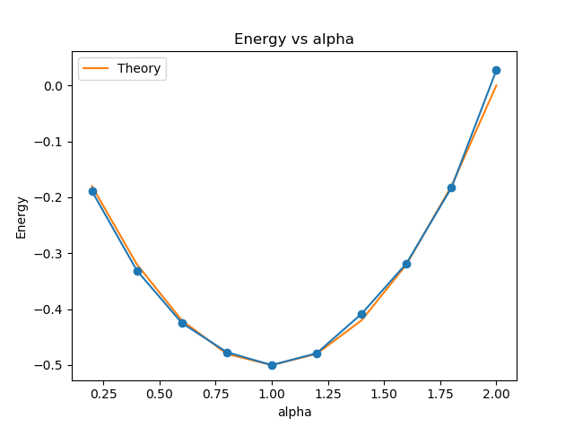

Comment on the comparison

As can clearly be seen here, in the limit as n → ∞ the analytical and numerical calculations coincide.

Problem 3:

Now, do the calculation for the Helium atom:
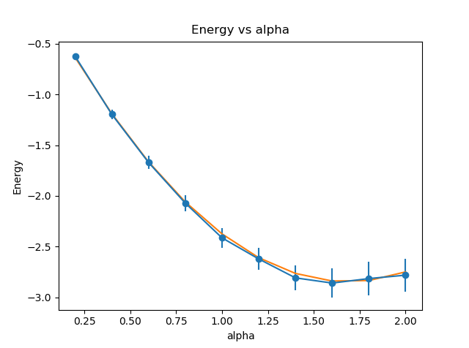
What is the minimizing value for α in this case? (Check your numerical answer by doing the minimization analytically.) What is the corresponding minimum value for EV ?

(See calculations on the following page)

